1. Change the source of pip for fast installation
2. deb http://mirrors.aliyun.com/ubuntu/ bionic main restricted universe multiverse
3. deb http://mirrors.aliyun.com/ubuntu/ bionic-security main restricted universe multiverse
4. deb http://mirrors.aliyun.com/ubuntu/ bionic-updates main restricted universe multiverse
5. deb http://mirrors.aliyun.com/ubuntu/ bionic-proposed main restricted universe multiverse
6. deb http://mirrors.aliyun.com/ubuntu/ bionic-backports main restricted universe multiverse
7. deb-src http://mirrors.aliyun.com/ubuntu/ bionic main restricted universe multiverse
8. deb-src http://mirrors.aliyun.com/ubuntu/ bionic-security main restricted universe multiverse
9. deb-src http://mirrors.aliyun.com/ubuntu/ bionic-updates main restricted universe multiverse
10. deb-src http://mirrors.aliyun.com/ubuntu/ bionic-proposed main restricted universe multiverse
11. deb-src http://mirrors.aliyun.com/ubuntu/ bionic-backports main restricted universe multiverse
12. install python3.6

set the install path prefix as /usr/local

1. ./configure --prefix=/usr/local/python3
2. sudo make && sudo make install

Error: configure: error: no acceptable C compiler found in $PATH

Resolve：build c/c++ compile environment

1. sudo apt-get update
2. sudo apt-get upgrade
3. sudo apt-get install build-essential

Error: uninstalled zlib

1. sudo apt-get install ruby
2. sudo apt-get install zlib1g
3. sudo apt-get install zlib1g.dev
4. install pip，and update pip source
5. sudo apt install python3-pip
6. pip3 --version
7. mkdir -p ~/.pip
8. gedit ~/.pip/pip.conf
9. install torch, scipy, numpy and other python packages
10. install cmake

sudo apt-get install autoconf automake libtool curl make g++ unzip

download cmake-3.18.2

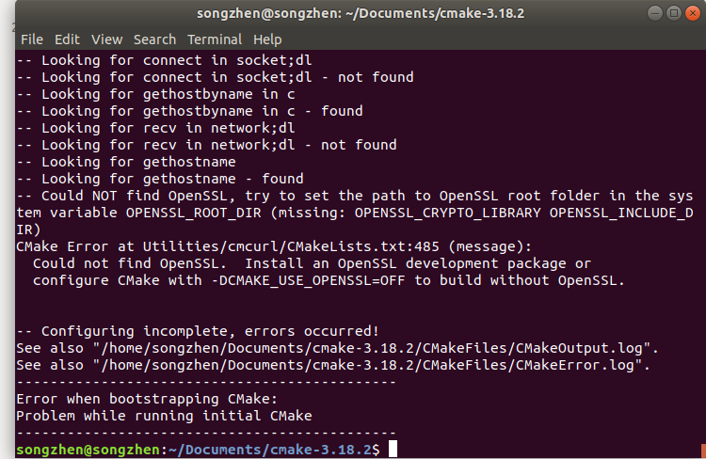

make

sudo make install

1. install protobuf +grpc

download source code of gRPC，and all gRPC submodules

install protobuf

1. cd grpc/third_party/protobuf/
2. git submodule update --init --recursive
3. sudo ./autogen.sh
4. sudo ./configure CFLAGS="-fPIC" CXXFLAGS="-fPIC"
5. sudo make
6. sudo make check
7. sudo make install
8. sudo ldconfig
9. which protoc
10. protoc --version

install dependent package absl of grpc

1. sudo apt-get update && sudo apt-get install -y libssl-dev
2. cd grpc/third_party/abseil-cpp/
3. sudo mkdir build
4. sudo cmake -DCMAKE_BUILD_TYPE=Release -DCMAKE_POSITION_INDEPENDENT_CODE=TRUE ..
5. sudo make install
6. cd grpc/third_party/cares/cares
7. mkdir build
8. cd build
9. sudo cmake -DCMAKE_BUILD_TYPE=Release ..
10. sudo make install

install grpc

1. mkdir build & cd build
2. sudo cmake -DCMAKE_BUILD_TYPE=Release \
3. -DgRPC_INSTALL=ON \
4. -DgRPC_BUILD_TESTS=OFF \
5. -DgRPC_CARES_PROVIDER=package \
6. -DgRPC_ABSL_PROVIDER=package \
7. -DgRPC_PROTOBUF_PROVIDER=package \
8. -DgRPC_SSL_PROVIDER=package \
9. -DgRPC_ZLIB_PROVIDER=package ..
10. sudo make install

sudo cmake -DCMAKE_BUILD_TYPE=Release \ -DgRPC_INSTALL=ON \ -DgRPC_BUILD_TESTS=OFF \ -DgRPC_CARES_PROVIDER=package \ -DgRPC_ABSL_PROVIDER=package \ -DgRPC_PROTOBUF_PROVIDER=package \ -DgRPC_SSL_PROVIDER=package \ -DgRPC_ZLIB_PROVIDER=package ..

test the example and make sure if the installation is successful ：

1. cd grpc/examples/cpp/helloworld
2. make
3. ./greeter_server
4. ./greeter_client

Error: cannot find protobuf-config.cmake

#find_package(Protobuf CONFIG REQUIRED)

ERROR: Cannot find libprotobuf.so.30

ERROR: Cannot find libpython3.6m.1.0

<https://www.cnblogs.com/yu121/p/14593107.html>